**Project Design Phase-I**

**Solution Architecture**

|  |  |
| --- | --- |
| **Date** | 23 September 2022 |
| **Team ID** | PNT2022TMID41909 |
| **Project Name** | Signs with Smart Connectivity for Better Road Safety |
| **Maximum Marks** | 4 Marks |

**Solution Architecture:**

* The vehicle monitoring system detects a potentially dangerous situation using in-vehicle and outside-vehicle sensors and wearable sensors on passengers, however, the accident is unavoidable and the car gets stuck in a recently formed road cavity. The car immediately starts the included security and safety protocols to perform a preliminary assessment of the situation.
* Through wearable sensors on the passenger, the car’s central system receives the information and performs an assessment of passengers’ health status.
* After assessing the vehicle’s damages and the passengers’ health status, the central system notifies the relevant parties such as :

**(i)** the vehicle insurer, sending information such as location, insurance policy number and preliminary damage assessment conducted from the information provided by different sensors.

**(ii)** emergency services, sending the accident notification including, but not limited to, the number of passengers, the passenger location inside the vehicle and vital signals of each passenger, among others.

* All the information about the accident, generated by the car’s systems and protocols and the road infrastructure is sent and stored in the cloud and made available for information systems to provide further information and notifications in real time to other drivers
* Location services such as: Google Maps, Apple Maps, Here We Go, and Waze can utilize the information to recalculate new or alternate routes to prevent road congestion or another accident.

**Architecture Diagram:**

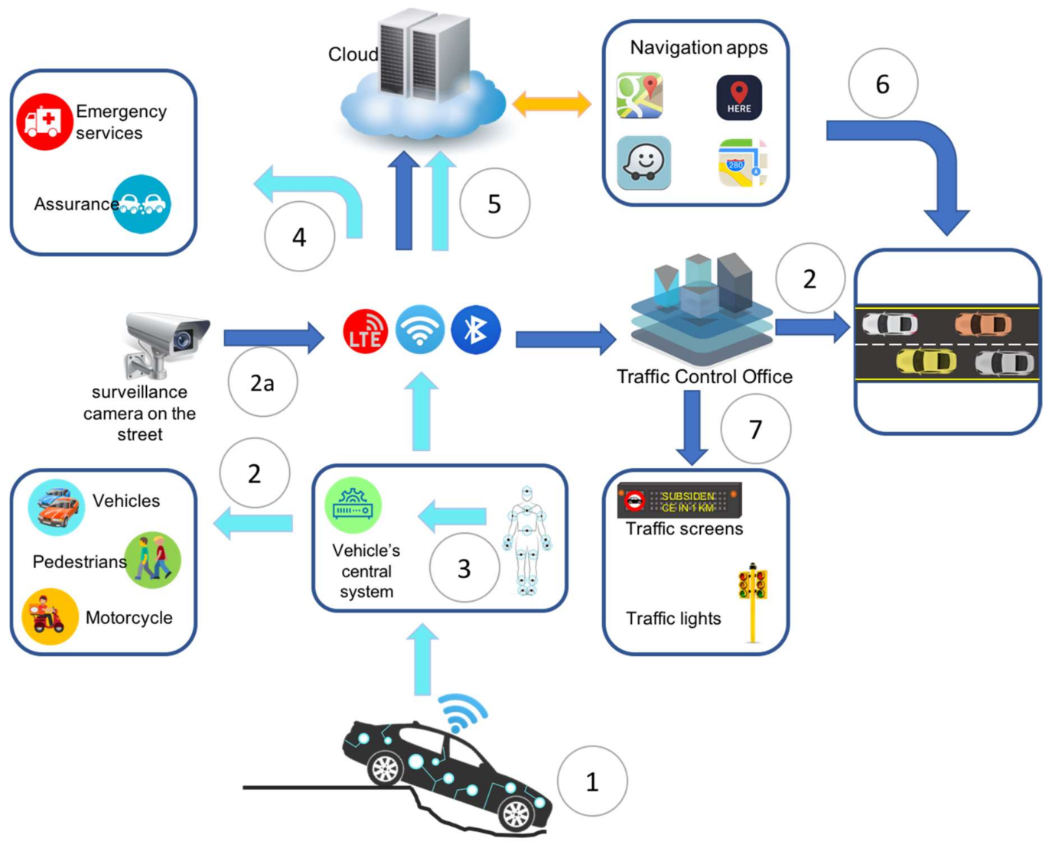

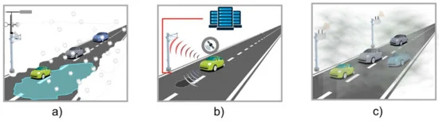

1. Road weather condition
2. Surface state
3. Pollution management